**Transportation Sharing**

✹

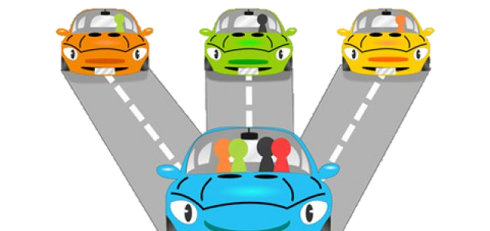

**GLOBAL MANUFACTURING STRATEGY**

Global Manufacturing Strategy

Tsinghua University

2015

**MyChe**



Challenges

Law & Public Policy

Technology Analysis

**Transportation Sharing**

Transportation Analysis

Market Analysis

Table of Contents

Team members 3

List of Tables & Figures 3

Executive Summary 4

Introduction 5

Concept of Carpooling 5

Carpooling over the years 5

World War II car-sharing clubs (1942-1945) 5

Major responses to the energy crises (1970-1980) 5

Early organized ridesharing schemes (1980 - 1997) 6

Reliable ridesharing systems (1999 - 2004) 6

Technology-enabled ride matching (2004 - to present) 6

Part 1: Market Analysis 7

Market size and Growth 7

Ride matching platform partnerships 8

“Green trip”-sponsored incentives 8

Social networking platforms 9

Real-time ridesharing services 9

Some companies 10

Part 2: Transportation Analysis 11

Environment Impacts 11

Shot Distance Trips 12

Long Distance Trips 13

Transportation Cost 13

Traffic Flow 13

Part 3: Technology Analysis 13

Used Technologies 13

Limited Possibilities 13

Technologies to boost the market 13

Part 4: Law and Public policy 14

Part 5: Social awareness 14

Part 6: Challenges 14

Conclusion 15

Appentix 15

References 16

# Team members

# List of Tables & Figures

Fig. 1 Propaganda for Carpooling during the Second World War. Sources: Oregon State Archives, US Archives and Records Administration 5

Fig. 2 Graph of oil prices during the years. (Wikipedia oil crisis 1973) 6

Fig. 3 Cars wait in long lines during the gas shortage in 70´s 6

Fig. 4 Interpolated and extrapolated carpool trends in the United States 1970-200. Source: The rise and fall of the American carpool: 1970–1990, Erik T. Ferguson & Associates, P.O. Box 888729, Dunwoody, Georgia 30356, USA 7

Fig. 5 International comparison of work trip modes shares. Sources: US Census, 2000 Journey to Work, StastCan, 2001 Commuting Patterns of Canadians, UK DfT, 1999 National Travel Survey, ABS, 2001 Census of Population & Housing 8

Fig. 6 North American Ride matching Services (July 2011). Sources: ITS Berkeley, Transportation Sustainability Research Center 8

Fig. 7 Zimride.com: Ridesharing with Facebook (USA 10

Fig. 8 Nuride.com 10

Fig. 9 Variation of Carpooling use with the distance. Source INSEE 2010 11

Fig. 10 CO2 Emissions for different scenarios. Source Canadian ministry of transportation 12

# Executive Summary

Ben Koo is a perfect teacher

# Introduction

## Concept of Carpooling

Carpooling is an option whether or not own or drive a car. If someone know that travel the same route as a neighbor or co-worker, consider arranging to carpool or ride-share. Carpooling is seen as a more environmentally friendly and sustainable way to travel as sharing journeys reduces [carbon emissions](http://en.wikipedia.org/wiki/Carbon_emissions), [traffic congestion](http://en.wikipedia.org/wiki/Traffic_congestion) on the roads, and the need for [parking](http://en.wikipedia.org/wiki/Parking) spaces. Authorities often encourage carpooling, especially during high pollution periods.

Carpool commuting is more popular for people who work in places with more jobs nearby, and who live in places with higher residential densities. Is significantly correlated with transport operating costs, including gas prices and commute length, and with measures of [social capital](http://en.wikipedia.org/wiki/Social_capital), such as time spent with others, time spent eating and drinking, and being unmarried. Is significantly less likely among people who spend more time at work, older workers, and homeowners.

## Carpooling over the years

### World War II car-sharing clubs (1942-1945)

Focus on conserving resources for the war. Car sharing clubs exchange and self-dispatching system. Matched riders and drivers via bulletin at work.



Fig. 1 Propaganda for Carpooling during the Second World War. Sources: Oregon State Archives, US Archives and Records Administration

### Major responses to the energy crises (1970-1980)

Grew significantly in the 1970s in response to the energy crisis and the Arab oil embargo of 1973 to 1974. Focus on conserving fuel. Employer and government sponsored ridesharing projects.

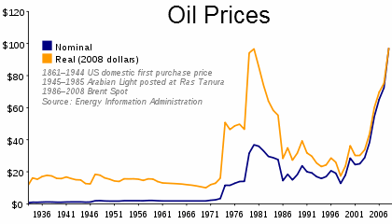

Fig. 2 Graph of oil prices during the years. (Wikipedia oil crisis 1973)

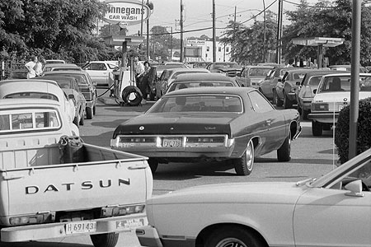

Fig. 3 Cars wait in long lines during the gas shortage in 70´s

### Early organized ridesharing schemes (1980 - 1997)

Focus on mitigating traffic congestion and air quality issues. Telephone based ride matching.

### Reliable ridesharing systems (1999 - 2004)

Focus on mitigate traffic congestion. Online ride matching services. Traveler information services.

### Technology-enabled ride matching (2004 - to present)

Focus on reducing climate change. Financial incentives for “green trips” through sponsors. Growing dependence on foreign oil and traffic congestion. Partnerships between ride matching software companies and regions and large employers. Internet, mobile phones, and social networking platforms. Real time ridesharing services.

# Part 1: Market Analysis

This period encompasses the fifth ridesharing phase, called: “technology-enabled ride matching”. In this period is most notable for the widespread integration of the Internet, mobile phones, and social networking (i.e. an online community where individuals connect and interact) into ridesharing services. At present, the majority of North American ride matching services use online websites as their chief technology medium. Many of them are based on a ridesharing software platform purchased from a private company. As of July 2011, there were approximately 12 such companies in North America that offer this software. (E.g. Ecology and Environment, Inc. offers Green Ridew, and Pathway Intelligence Inc. provides Jack Bell Ride-Share). While the abundance of online ridesharing systems is promising, it has resulted in disparate, non-standardized databases that leave many programs with a lack of critical mass.

There are approximately 638 ride matching programs in North America.

As of July 2011, the authors estimated that there were 638 ride matching services in North America, based on an extensive Internet search. This tally includes both online (most have an Internet-based component) and offline carpooling and vanpooling programs. Those located in sparsely populated rural areas, which appeared to have very low use, were excluded. Institutions that have their own ride matching website but employ a common platform were each counted separately. Of the total, 401 are located in the USA, and 261 are in Canada (24 programs span both countries). Carpooling attracts the largest focus, with 612 programs offering ride matching, and 153 providing vanpool ride matching; 127 offer both.

## Market size and Growth

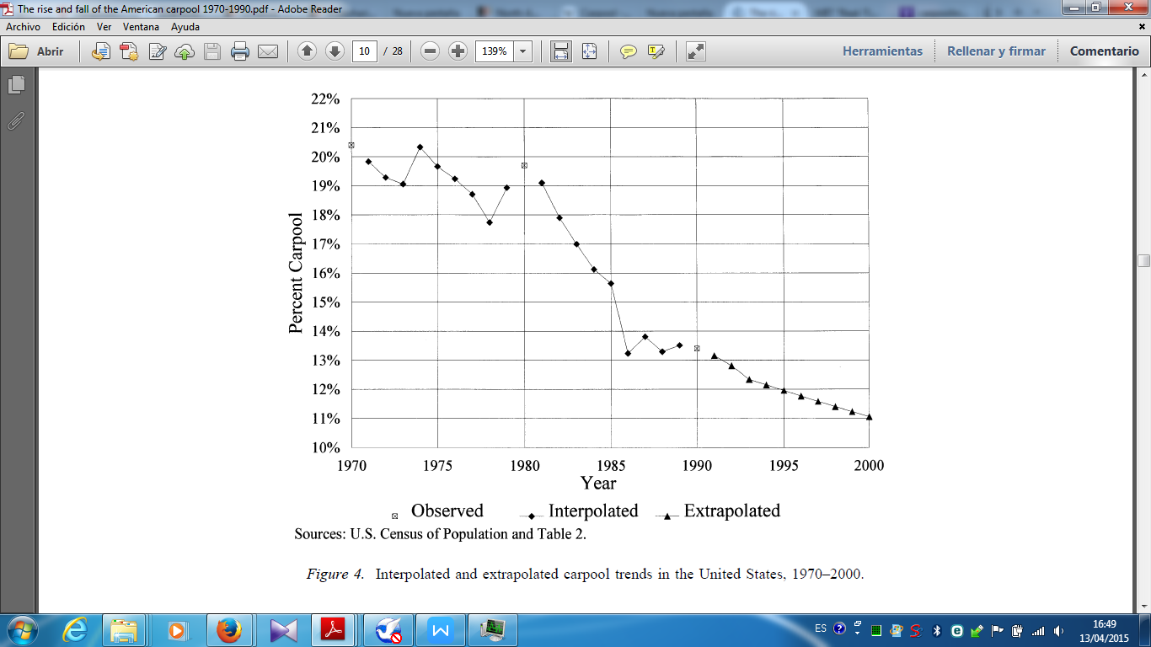

Fig. 4 Interpolated and extrapolated carpool trends in the United States 1970-200. Source: The rise and fall of the American carpool: 1970–1990, Erik T. Ferguson & Associates, P.O. Box 888729, Dunwoody, Georgia 30356, USA

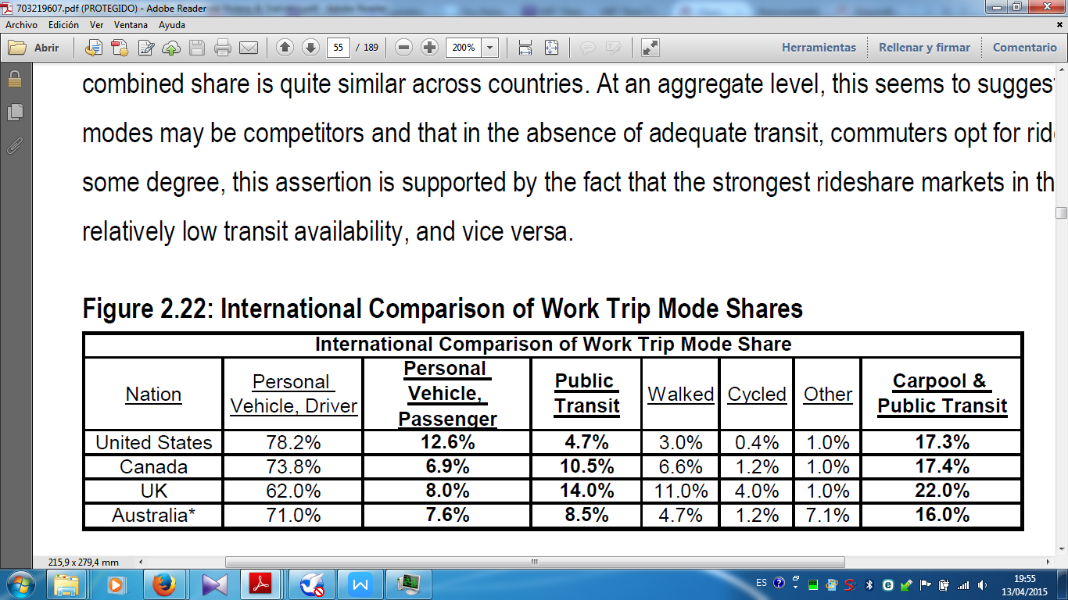

Fig. 5 International comparison of work trip modes shares. Sources: US Census, 2000 Journey to Work, StastCan, 2001 Commuting Patterns of Canadians, UK DfT, 1999 National Travel Survey, ABS, 2001 Census of Population & Housing

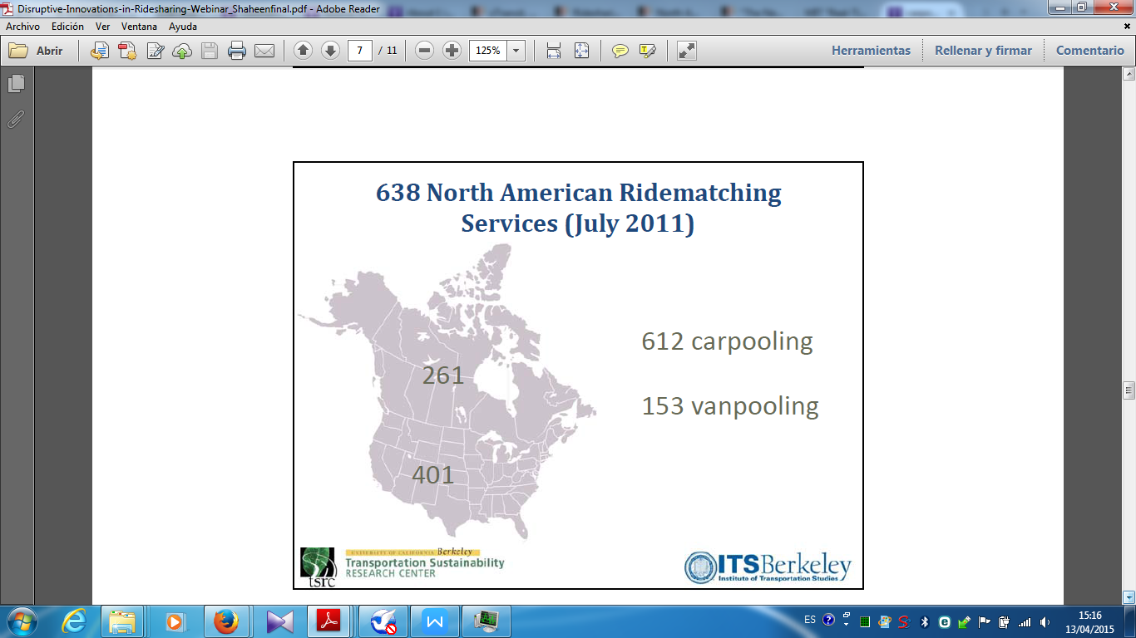

Fig. 6 North American Ride matching Services (July 2011). Sources: ITS Berkeley, Transportation Sustainability Research Center

## Ride matching platform partnerships

From 2004 to the present, a new generation of ride matching platforms has been developed for regions and employers to use. Moreover, there has been significant growth and overall success with this strategy. Partnerships between ride matching software companies and its large-scale clients take advantage of existing common destinations and large numbers of potential members. These firms sell their ride matching software “platforms” to public agencies and employers, which are sometimes used as standalone websites for each group. While this partnership strategy has gained more users than previous ridesharing phases, it is most suited for commuters with regular schedules.

## “Green trip”-sponsored incentives

Many public agencies and companies promote ridesharing by providing its members with incentives. One example is NuRide—an online ridesharing club with over 63 000 members in seven US metropolitan areas (NuRide, 2011). NuRide rewards points when members carpool, vanpool, take public transit, bike, walk, or telecommute for both work and personal trips. These points can be used for restaurant coupons, shopping discounts, and attraction tickets. NuRide partners with public agencies, employers, and businesses to sponsor the incentives. Similarly, RideSpring works with employer commute programmes and participating employees can enter monthly drawings for prizes from over 100 retailers (RideSpring, 2010).

## Social networking platforms

The rise of social networking platforms, such as Facebook, has enabled ridesharing companies to use this interface to match potential rides between friends or acquaintances more easily. These companies hope that social networking will build trust among participants, addressing safety considerations. One example is Zimride, which has partnered with 86 US and Canadian colleges, universities, and companies that each has their own “network” of members (Zimride, 2011). In addition to each network’s website, Zimride also uses the Facebook platform to attract public users. Another service is PickupPal (2011), with over 156 000 members in 120 countries. It allows members to create their own groups based on common area, company, school, and shared interests. However, social networking may limit itself by relying on more isolated groups and excluding less tech-savvy users. At present, there are four major North American ridesharing programmes focused on social networking: GoLocoTM, Gtrot, PickupPal, and Zimride.

## Real-time ridesharing services

In North America, two companies are beginning to offer real-time ridesharing services: AvegoTM and Carticipate. Real-time ridesharing uses Internet-enabled “smartphones” and automated ridematching software to organize rides in real time. This enables participants to be organized either minutes before the trip takes place or while the trip is occurring, with passengers picked up and dropped off along the way. These programmes attempt to address the inconvenience of traditional carpooling and vanpooling. As in most ridesharing services, a high subscriber base is required. These key developments and their target journey purposes are summarized in ´Table 3.

## Some companies

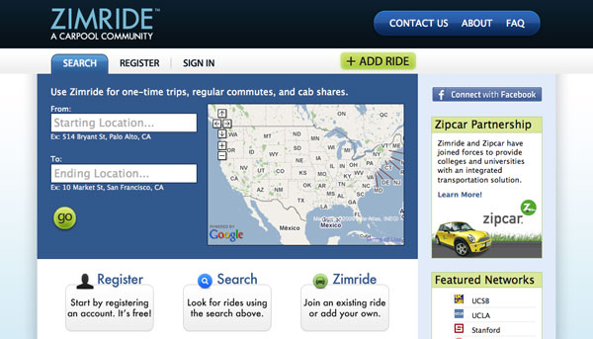

Fig. 7 Zimride.com: Ridesharing with Facebook (USA

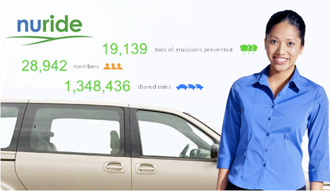

Fig. 8 Nuride.com

# 

# Part 2: Transportation Analysis

## Environment Impacts

Fig. 9 Contribution on transportation to the atmosphere pollution. Source http://www.ec.gc.ca

The part of atmosphere pollution due to the transportation is very high in the big cities. For these areas, we consider that the transportation by road is the first responsible of emission of NOx and PM10 particles. The process of emission of those particles is:

* The VOC (Volatile organic compounds): those particles are emitted directly from the exhaust of cars.
* NOx: some of those particles are emitted by the engine and some others are produced by chemical reactions in the atmosphere due to the NOx emitted.
* PM10 and PM2.5 are emitted or created by the VOCs. There volatility is due to the traffic.

In this part we are going to calculate the ecological impact of using carpooling. We are limiting our study of ecological impact to the CO2 emission during the travels. Our statistics are collected from the last ENTD (a French study which is made each 10 years to know how French people are traveling). The study was made with a sample of 20200 representative households of the national (France) tendency.

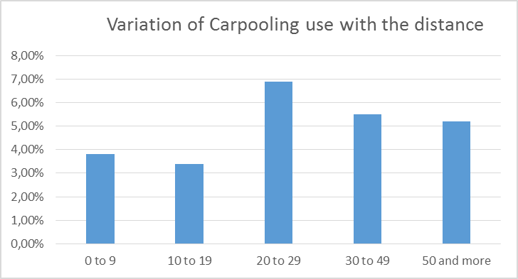

Those figures are showing that the most important use of carpooling is related to travels between 20 and 30 km.

Fig. 10 Variation of Carpooling use with the distance. Source ENTD 2010

### 

Fig. 11 Variation of occupation rate for a type of travels. Source ADEME 2013

### Shot Distance Trips

We learn from ENTD’s figures that, the mean distance between house and work place is 14.7km.

This simulation is made for:

* round trip
* 5 working days per week and
* 52 working weeks in the year.

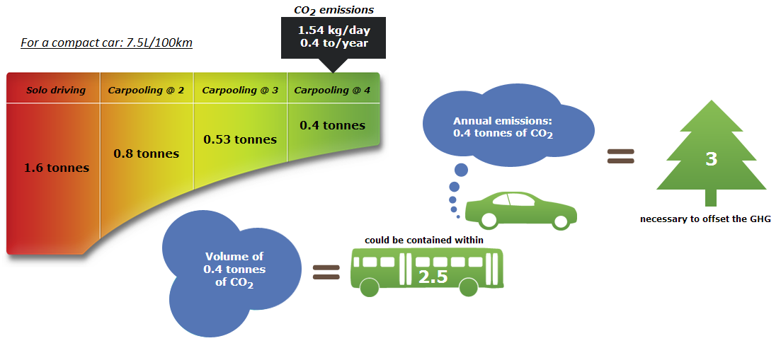

Fig. 12 CO2 Emissions for different scenarios with small car. Source Canadian ministry of transportation

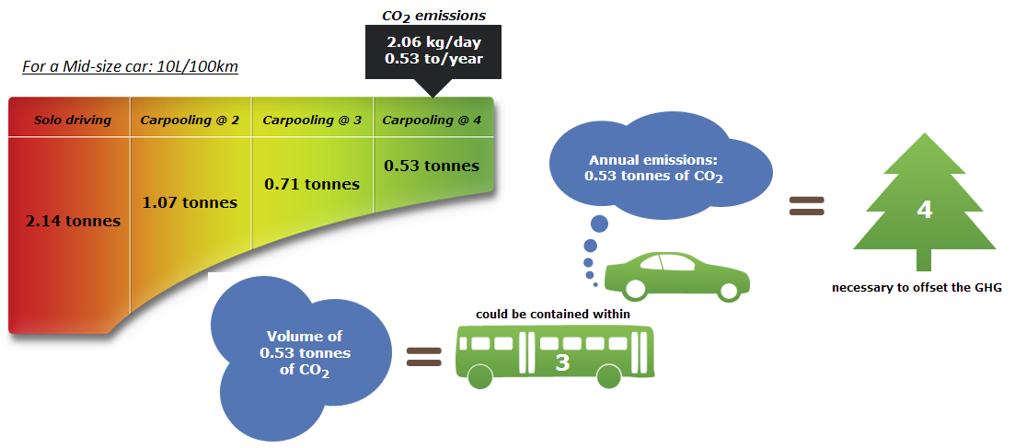

Fig. 13 CO2 Emissions for different scenarios with medium car. Source Canadian ministry of transportation

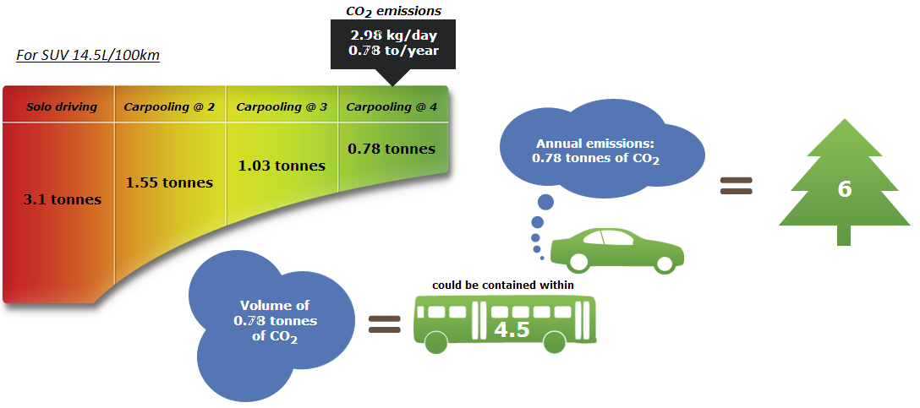

Fig. 14 CO2 Emissions for different scenarios with SUV. Source Canadian ministry of transportation

### 

Eplanations about the calculation and the assumptions

[Sidebars are great for calling out important points from your text or adding additional info for quick reference, such as a schedule.

They are typically placed on the left, right, top or bottom of the page. But you can easily drag them to any position you prefer.

When you’re ready to add your content, just click here and start typing.]

Increasing the occupation rate

From 1.2 To 2

Will reduce the CO2 emissions by

With

=

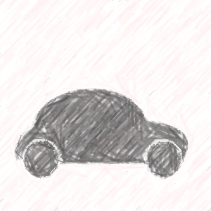

**31.6 M cars in**

**France in 2013**

0.71Tonnes

Per Year, per Car



* 12%

Of the total emitted in France by transportations



### Long Distance Trips

*[Grab your reader’s attention with a great quote from the document or use this space to emphasize a key point. To place this text box anywhere on the page, just drag it.]*



* 1000 Million tonnes per year



* 84 Million tonnes per year

*[Grab your reader’s attention with a great quote from the document or use this space to emphasize a key point. To place this text box anywhere on the page, just drag it.]*

*From the previous part, we estimated the emission due to short travels and the potential to reduce this value.*

*Regarding the percentage of long distance trips, and by ponderation operation, we estimate the total reduction of CO2 emissions in France*

## Transportation Cost

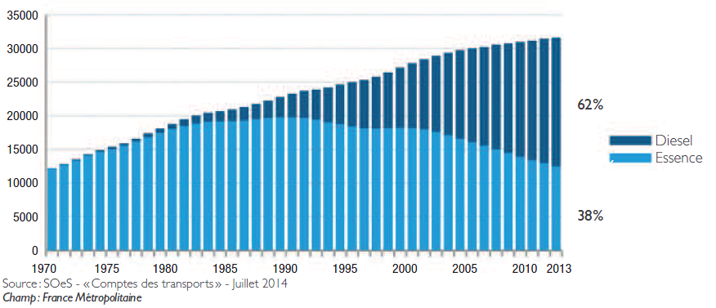

## Traffic Flow

# Part 3: Technology Analysis

## Used Technologies

## Limited Possibilities

## Technologies to boost the market

# Part 4: Law and Public policy

## Limits of Institutional Collaboration

# Part 5: Social awareness

## Security

## Motivations

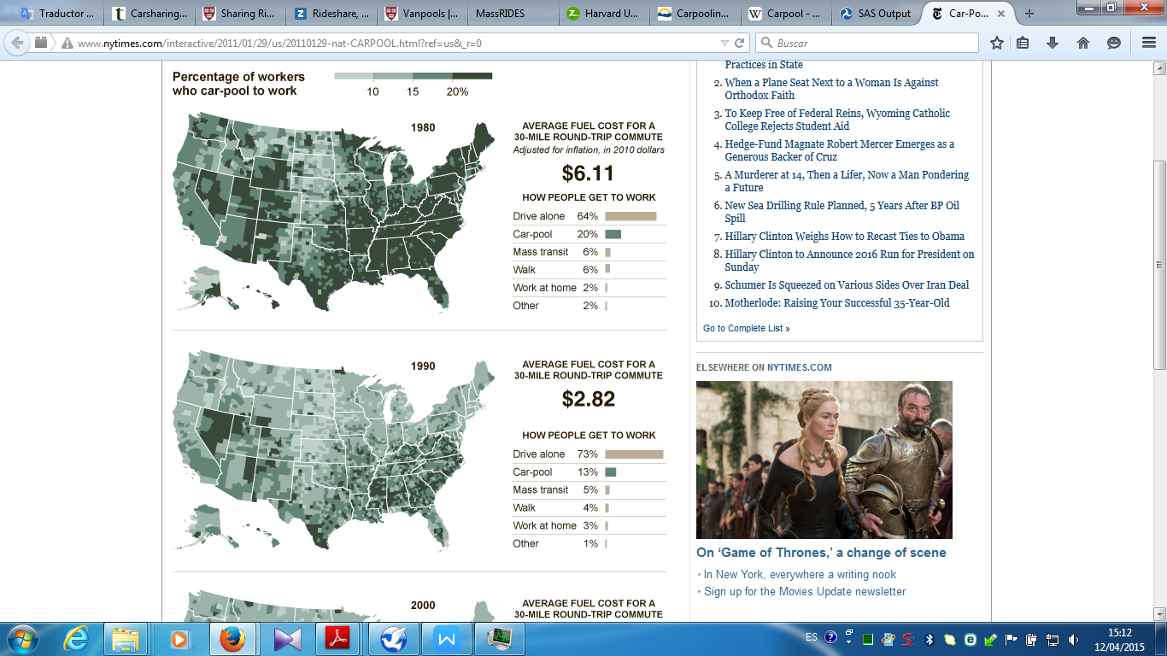

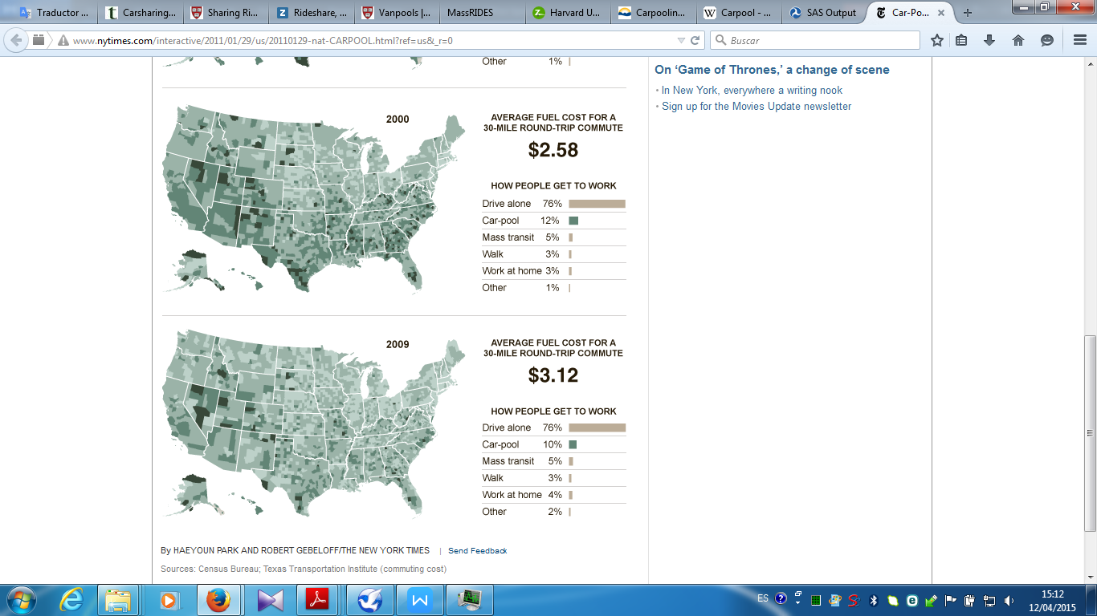

Fig. 13 Relation between oil prices and carpooling, Park, Haeyoun; Gebeloff/, Robert (28 January 2011). "Car-Pooling Declines as Driving Becomes Cheaper". The New York Times

# Part 6: Challenges

# Conclusion

# Appentix

# 

# References

ADEME. «ALLÉGER L’EMPREINTE ALLÉGER L’EMPREINTE DE LA CONSOMMATION DES FRANÇAIS EN 2030.» 2014.

*Leviers d’actions pour favoriser le covoiturage de courte distance, évaluation de l’impact sur les polluants atmosphériques et le co2*. France, 2014.

Amey, Andrew M. *Real-Time Ridesharing: Exploring the Opportunities and Challenges of Designing a Technology-based Rideshare Trial for the MIT Community*. Massachusetts Institute of Technology, 2010.

ATEMA. «CARACTERISATION DE SERVICES ET USAGES DE COVOITURAGE EN FRANCE.» *ADEMA* (2010).

CERTUS. «LES CHIFFRES CLÉS 2014 CLIMAT, AIR ET ÉNERGIE .» 2014.

durable, Ministaire developpement. *http://www.statistiques.developpement-durable.gouv.fr/transports/trv/deplacement-mobilite/mobilite-reguliere-locale.html*. s.d.

Lyon, Mairie de. *RAPPORT D’ANALYSE DE L’ENQUETE 2011*. Lyon, 2011.

Ministère de l’Écologie, du Développement durable et de l’Énergie. «Le covoiturage en France et en Europe: État des lieux et perspectives.» 2007.

«Politiques climat et efficacité énergétique.» *Ministère de l’Écologie, du Développement durable et de l’Énergie* (2013).